**Faculdade de Engenharia da Universidade do Porto**



Ship Escape

LCOM Final Project – Class 4 – Group 2

Made by:

João André Silva Roleira Marinho, up201905952

Table of Contents

**Introduction 4**

**1. User instructions 5**

**1.1 Main Menu 5**

**1.1.1 Date 5**

**1.1.2 Exit 6**

**1.2 Play Menu 7**

**1.2.1 Game map 8**

**1.2.2 Pause menu 9**

**1.2.3 Opponents 10**

**1.2.4 Tasks 11**

**1.2.5 Victory/Defeat 12**

**1.2.6 Rooms 13**

**1.3 Instructions menu 14**

**1.4 Best Scores menu 15**

**2. Project status 16**

**2.1 Subsecção - Estilo “Heading 2” = “Título 2” 16**

**2.1.1 Subsubsecção - Estilo “Heading 3” = “Título 3” 16**

**2.1.2 Numeração das secções 16**

**2.1.3 Equações 16**

**2.1.3 Figuras e tabelas 17**

**2.1.4 Citações 18**

**3. Code organization/structure 19**

**4. Implementation details 20**

**5. Conclusions 21**

# Introduction

The final project consists of a 2D game, Ship Escape, which is in a Top-Down view, although the idea of depth created by its background.

The player, an astronaut, who is trying to save his crew mates from the space invaders, has X amount of seconds to complete all the tasks distributed around the map while avoiding to get killed by these creatures. If the time expires the player loses the game and can restart it as many times as he wants.

In order to finish the tasks, he may use the mouse and/or the keyboard, he may as well kill the opponents with his projectiles, but careful you can only shoot again when the projectile disappears.

# User instructions

## Main Menu

As soon as you start the game, the following menu is displayed:

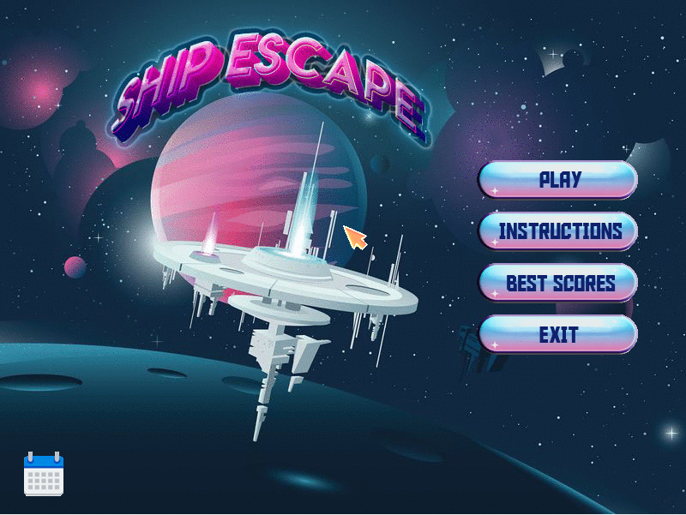

Figure 1. Main menu image

There are four possible options: PLAY, INSTRUCTIONS, BEST SCORES and EXIT.

With the movement of the mouse, you can control the cursor that you see on the screen and by clicking with the left mouse button you can choose one of the options stated before.

### Date

By hovering with the cursor over the calendar in the left bottom corner the current date will be displayed, and the calendar will change colour:



Figure 2 Calendar with date overview

### Exit

If you select the EXIT option, the program will shut down (end the game).



Figure 3 Exit button image

## Play Menu

By pressing the PLAY option,



Figure 4 Play button image

the real game begins, the player starts in what is called the CAFETERIA room in the centre of the screen. The countdown time is shown and starts decreasing right away.

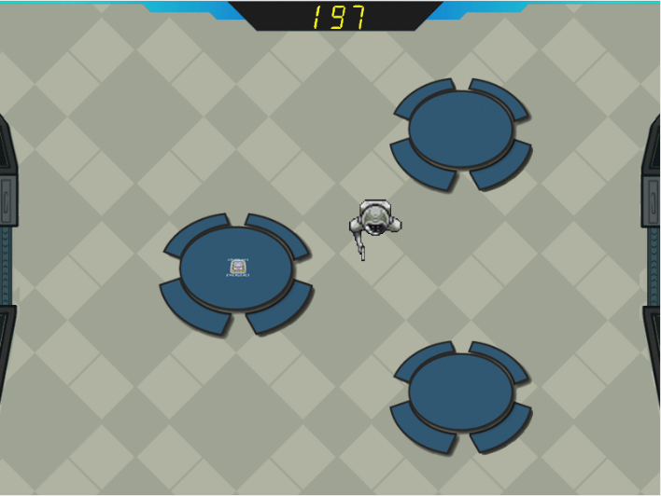

Figure 5 Cafeteria room image

The player movement is controlled with the keyboard, both with the W, A, S, D keys or with the up, left, down, right arrow keys.

The player may travel around the map passing through the doors and existing hallways.

### Game map

Concerning the orientation of the player throughout the game there exists a game map menu that can be accessed with the M key in the keyboard. There, the player obtains information on which room he must go for the remaining tasks, but he may need to be fast because the clock never stops. If he wants to leave this menu both the ESC and M key may be used.

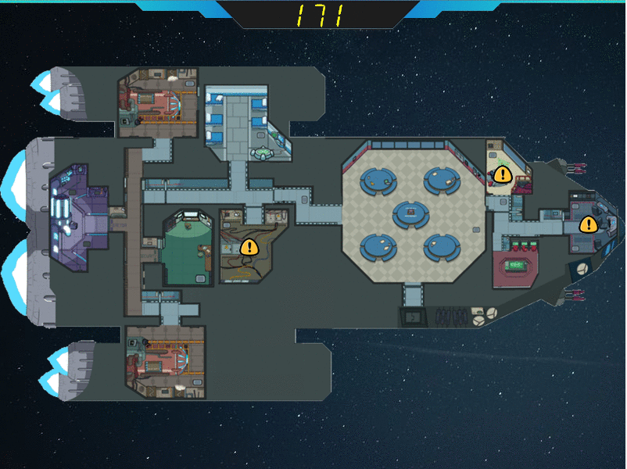

Figure 6 Game map image

### Pause menu

If the player needs a break or wants to go back to the main menu, he may do it by pressing the ESC key in the playing mode. This will load the pause menu, where the countdown stops, and two options are available: RESUME and MENU.

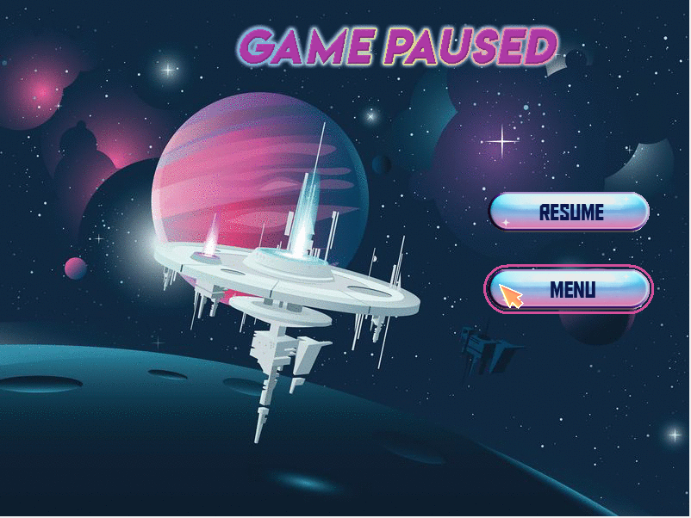

Figure 7 Pause menu image

If selected, the resume button will take the player back to the previous state of the game. On the other hand, the menu button loads the main menu once again, where he can restart playing the game from the very beginning.

### Opponents

Throughout the map are distributed opponents:

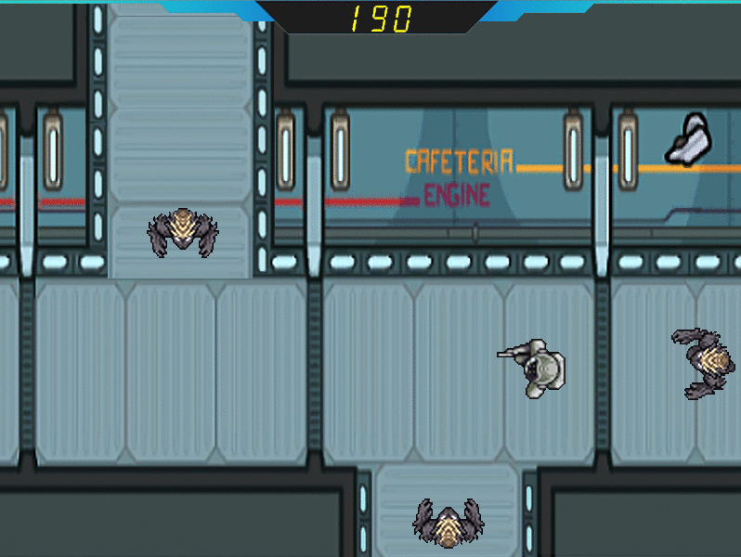

Figure 8 Hallway3 image with opponents

These little creatures will make the player’s mission a struggle. In order to survive the player must dodge the monsters, or with the help of is gun he may shoot his projectiles towards them using the SPACE BAR key in the keyboard, otherwise they will attack and kill him. Once the player is dead the defeat menu will be loaded.

So that the game becomes more fun, from time to time the fallen invaders will come back to life and try to kill the adventurer.

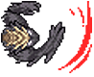

Figure 9 Opponent attack final animation

### Tasks

The main objective of the player, said previously, is to complete all the tasks before he runs out of time. Their locations are shown in the game map and appear in the room pointed by a yellow arrow.

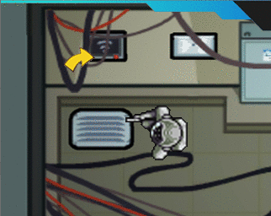

Figure 10 Arrow pointing to task image

There are different types of tasks, the ice task, the ship task, the download task, and others. The player may activate a task by pressing the E key in the keyboard, if he is close enough to it, the task will appear on the screen.

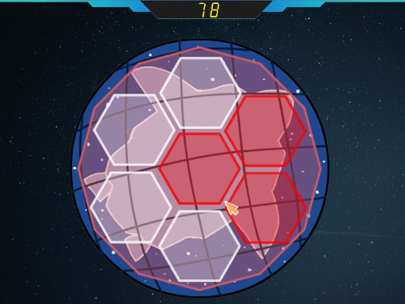

# 

Figure 11 Ice task image

# 

Figure 12 Ship task image

Figure 13 Download task image

### Victory/Defeat

The player either wins or loses the game, if he wins, the victory screen will be loaded showing the message of success and the points collected with the run, the faster the player finishes the tasks the more points he gets. If he gets a score worthy of the top 5 scores it will be available to check in the Best Scores menu.

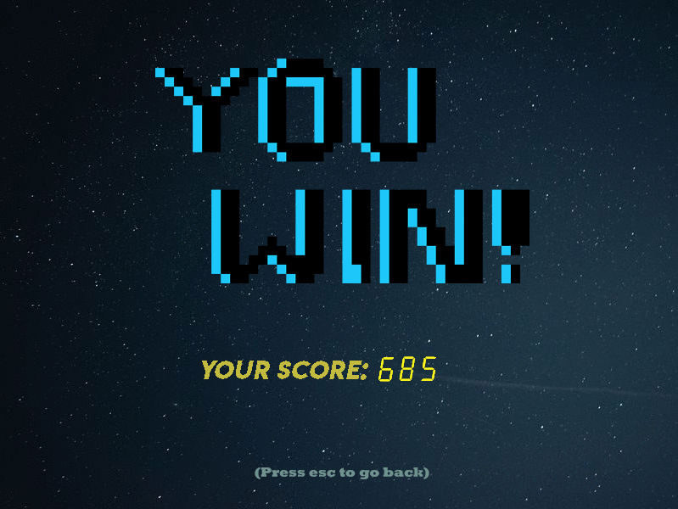

Figure 14 Victory screen image

Moreover, if the player loses, the defeat screen will be loaded. In both menus the player must use the ESC key to retrieve to the main menu.

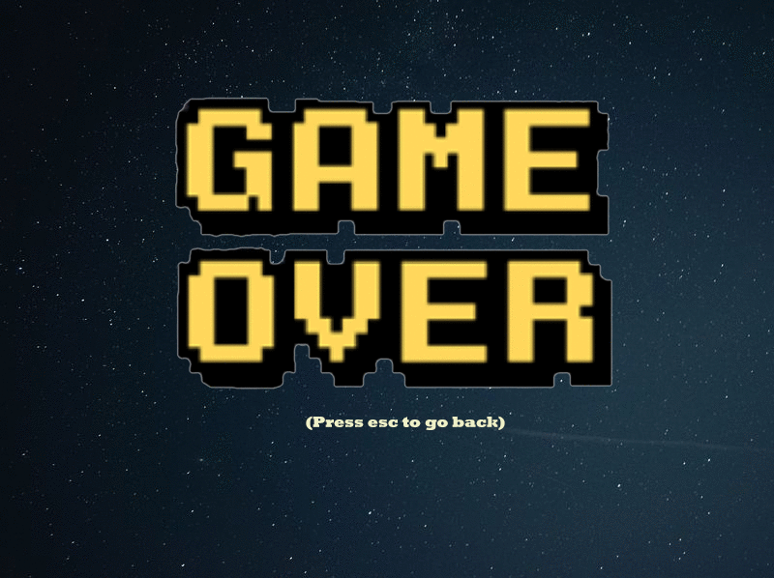

Figure 15 Defeat screen image

### Rooms

The different locations the map is made of are the rooms. Each room has a different number of opponents and tasks. Some examples are the cafeteria, navigation, electrical, weapons, security, reactor as well as 3 hallways and others.

# 

# 

Figure 16 Navigation room image

# 

# 

Figure 17 Admin room image

## Instructions menu

In the main menu after the player selects the INSTRUCTIONS button, the game objective and instructions will be displayed on the screen as the following:

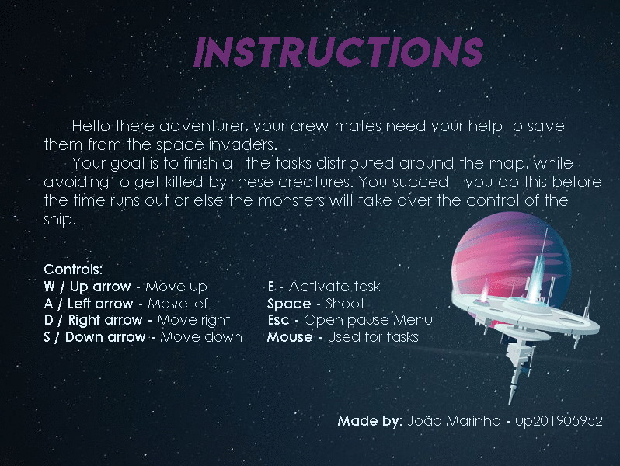

Figure 18 Instructions menu image

In order to leave this menu, the player must press the ESC key.

## Best Scores menu

The best scores menu, saves the 5 best scores achieved in the program run with the respective date provided by the RTC interrupts. These are displayed by descending order in terms of points gained.

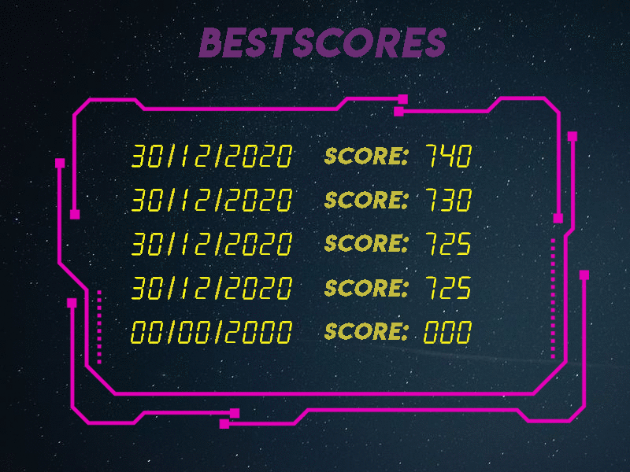

Figure 19 Best Scores menu image

In order to leave this menu, the player must press the ESC key.

# Project status

|  |  |  |
| --- | --- | --- |
| Device | Purpose | Interrupts |
| Video card | Display the game and all its menus | N / A |
| Keyboard | Player movement, access the map, activate tasks, and shoot projectiles | Yes |
| Mouse | Choose menu options and control tasks | Yes |
| Timer | Controls the frame rate, and the characters animations as well as the count down time. | Yes |
| RTC | Display the current date | Yes |

## 2.1 Video card

|  |  |  |  |
| --- | --- | --- | --- |
| Mode | Screen Resolution | Colour Mode | Number of Colours |
| 0x115 | 800x600 pixels | (8:8:8) 24 bits per pixel (direct mode) | 16.8M (2^24) |

In this project the Double Buffering technique was used to help the game transitions and the animation of all characters. This approach consists of having a backend buffer in which all the information is copied to the main one after a timer interrupt with the function copy_to_vram.

Many are the animations present in the game, the movement of the player and the opponents, the collision of the projectiles, the attack of the opponents and each task animations.

The player has a sequence of 8 animations, all facing the same way (right), these change according to the timer ticks and if the player is moving or not. The player movement is obtained by erasing his last position and drawing him again in the new one (x0+xspeed if moving horizontally and the same for y), this way there is no need to go through all the resolution of the screen in other to draw a rather small object.

To draw the player as well as all other objects that have a direction related to them, facing other directions, their pixmap are read in different ways so that they are looking the direction desired.

Aside from the movement there are other animations such as the attack of the opponent and the explosion of the projectile, that work similarly to the ones referred previously.

The collision between the player, opponent or projectiles with the room obstacles is made with the help of a xpm that has in white the area which the objects can move, and not white the area where the obstacles are located. Thus, the verification is made pixel by pixel when the object is moving.

The collision between the player with the opponents and the projectiles, are verified by their next timer interrupt position, if an opponent is hit with a projectile he dies and disappears, if an opponent attacks a player, the last one only disappears when the slash of the opponent is done.

All the images in the game use xpms. Most edited in photoshop and downloaded from the web, with free usage.

## 2.2 Keyboard

The keyboard is mainly used to control the movement of the player and access certain menus.

# 

# 3. Code organization/structure

*[Este capítulo trata algumas questões técnicas relativas à utilização pragmática dos “Documentos do Google” na FEUP. Não se pretende dizer que deva existir um capítulo de “Questões Técnicas”]*

Algumas “dicas”:

* É possível diversas pessoas alterarem o documento ao mesmo tempo
* Tendo ligação à internet, o documento está sempre gravado
* Todas as alterações e respetivo autor ficam registadas
* É possível ver as versões anteriores do documento
* É possível comunicar ao mesmo tempo (*hangout*) que se escreve no documento
* Utilize o navegador de internet *Chrome* e depois prima CTRL+Shift+F e depois F11 para maximizar a área de trabalho;
* De preferência utilizar uma conexão à internet via cabo (isto é, não wireless);
* A numeração de tabelas e figuras é mais simples se for ser feita manualmente;
* Inserir quebras de página através de CTRL+Enter
* Submeter sempre um documento *.PDF final para garantir que o aspeto do documento é “inalterável” e que a impressão ficará correta.

# 

# 4. Implementation details

[Apresentação clara e organizada das deduções ou ilações extraídas após a discussão dos resultados do estudo, como forma de responder à pergunta inicial do projeto. Por esse motivo não deve ser um texto de detalhe, nem um texto em que se apresente algo de novo, mas um texto de afirmação que deve ser lido de forma independente do restante relatório.

Para saber mais consulte o tutorial online “[Guia de Apoio à Publicação](https://docs.google.com/document/d/1TDC1behVq8x7fQL4CcPEEh_np5GXviJevQxnQ9gbiJs/edit#heading=h.esrnyfxdz3z)”.]

# 5. Conclusions

[Elemento opcional.

Se forem breves, podem ser incluídas nas conclusões. Se forem mais extensas, devem figurar em separado.